ACADEMIC STAFF APPRAISAL MODEL

The Academic staff model uses these four criteria for its appraisal scoring which are:

i. Overall output quantity for course
ii. Worth of Quality
iii. Points
iv. RTP (Relative to Target Performance)
Form one to four (For Setting) are to be filled by each individual staff once during an appraisal period if necessary.
Figure 1 (FORM 1) Note: In place of University Name use Institution Name in your design.

figure 2 (FORM 2)

Figure 3 (FORM 3)

Figure 4 (FORM 4)
These forms are FORM 8, FORM 9, FORM 10, FORM 11 and FORM 12. Below are input form needed to take input for the actual appraisal exercise. see sample of already designed data entry for these forms in
figure 8, (Student/Teacher Form)
Note: only to be assessed by the departmental registered admin in the software. This form is also to be made printable by the Departmental Admin registered staff
Designed from the below table.
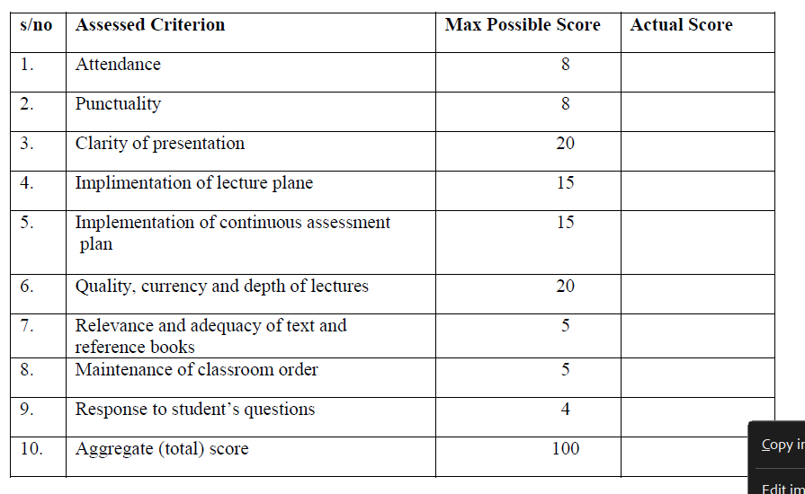
figure 9, (Teaching quality evaluation form) to be assessed by the appraise staff for filling.
Designed from the below table.
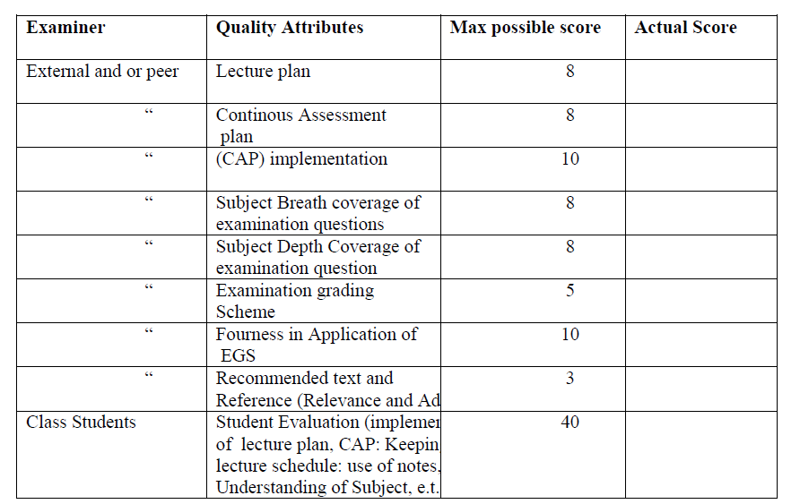

figure 10, (Research quality evaluation form) to be assessed by the appraise staff for filling.
Designed from the below table.
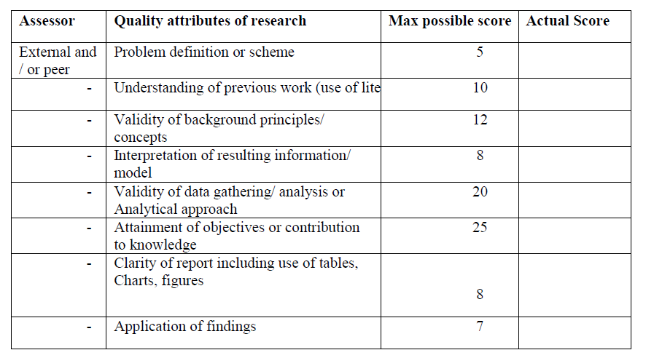


figure 11 (Administration quality evaluation form) to be assessed by the appraise staff for filling.
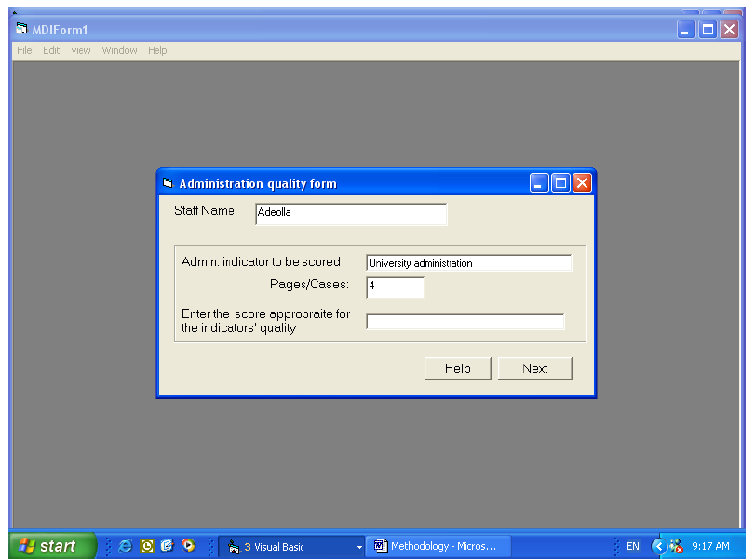
Designed from the below table.

figure 12 below.
Designed from the below table
Overall Judgment Check pages to page 27 of the full and complete document
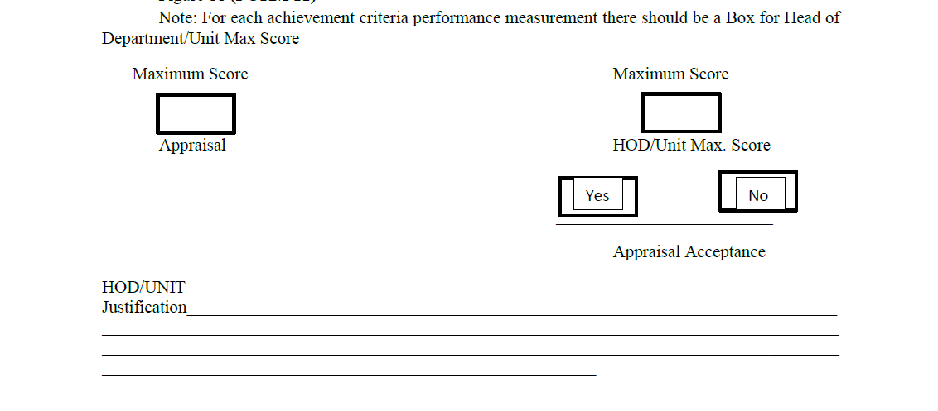
NON-ACADEMIC STAFF APPRAISAL MODEL
For Non- Academic staff appraisal model (For non academic staff in learning institutions, Company, and public/Civil servant Organization) the following criteria is used for its scoring which are:
i. Overall output quantity for course
ii. Worth of Quality
iii. Points
iv. RTP (Relative to Target Performance)
Figure 8 (FORM 8) TO BE KNOW AS ACTIVITY FORM to be use to determine the entry score for Hardwork (quantity) in staff appraisal sample adopted from Academic staff Appraisal. Use the table below to build a data entry form like in form 8 under Academic Appraisal.
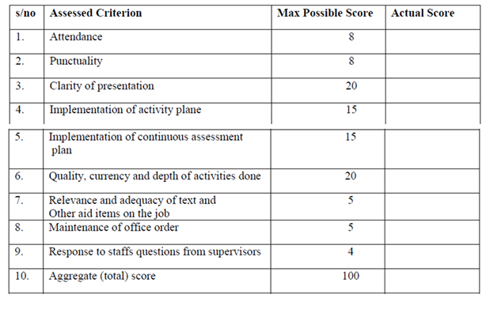

Figure 9 (FORM 9) TO BE KNOW AS Training Quality FORM to be use to determine the entry score for Training on the job (quality) in staff appraisal sample adopted from Academic staff Appraisal. Use the table below to build a data entry form like in form 9 under Academic Appraisal.
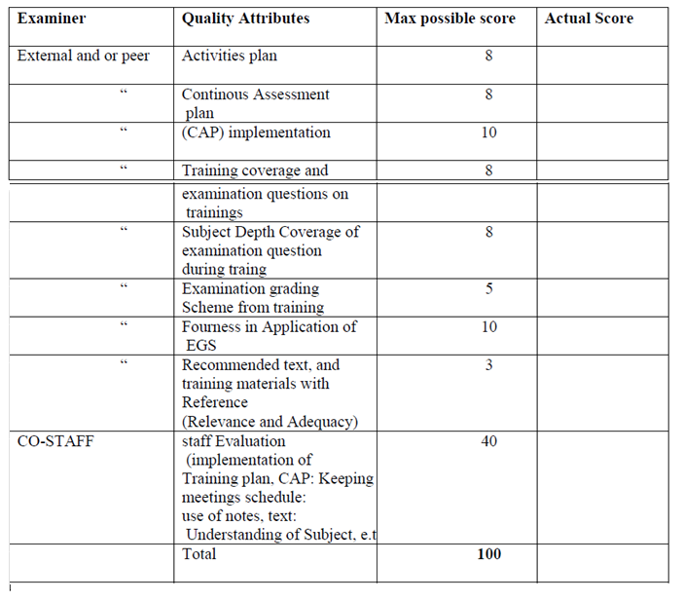

Figure 10 (FORM 10) TO BE KNOW AS Fault Solving Quality Attribute FORM to be use to determine the entry score for Training on the job (quality) in staff appraisal sample adopted from Academic staff Appraisal. Use the table below to build a data entry form like in form 10 under Academic Appraisal.
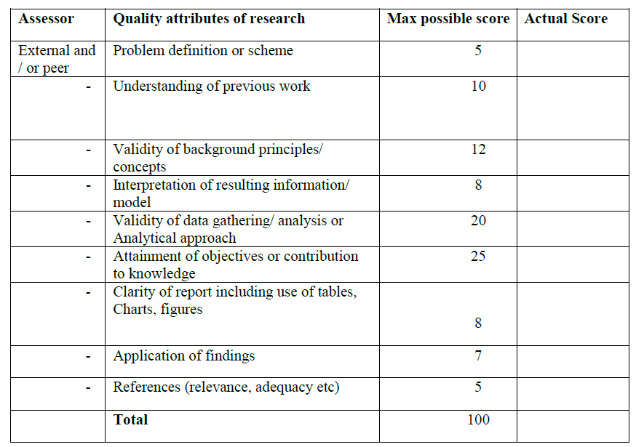
Final Judgment acceptance/rejection section
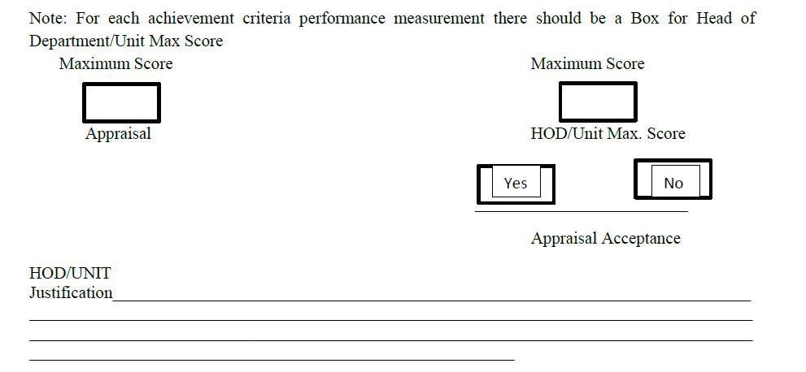

You can find the above in the full and complete document from pages 82 to page 86. But use the same model for the scoring as with Academic except that the target points will be restructured for this Appraisal.

